State of California
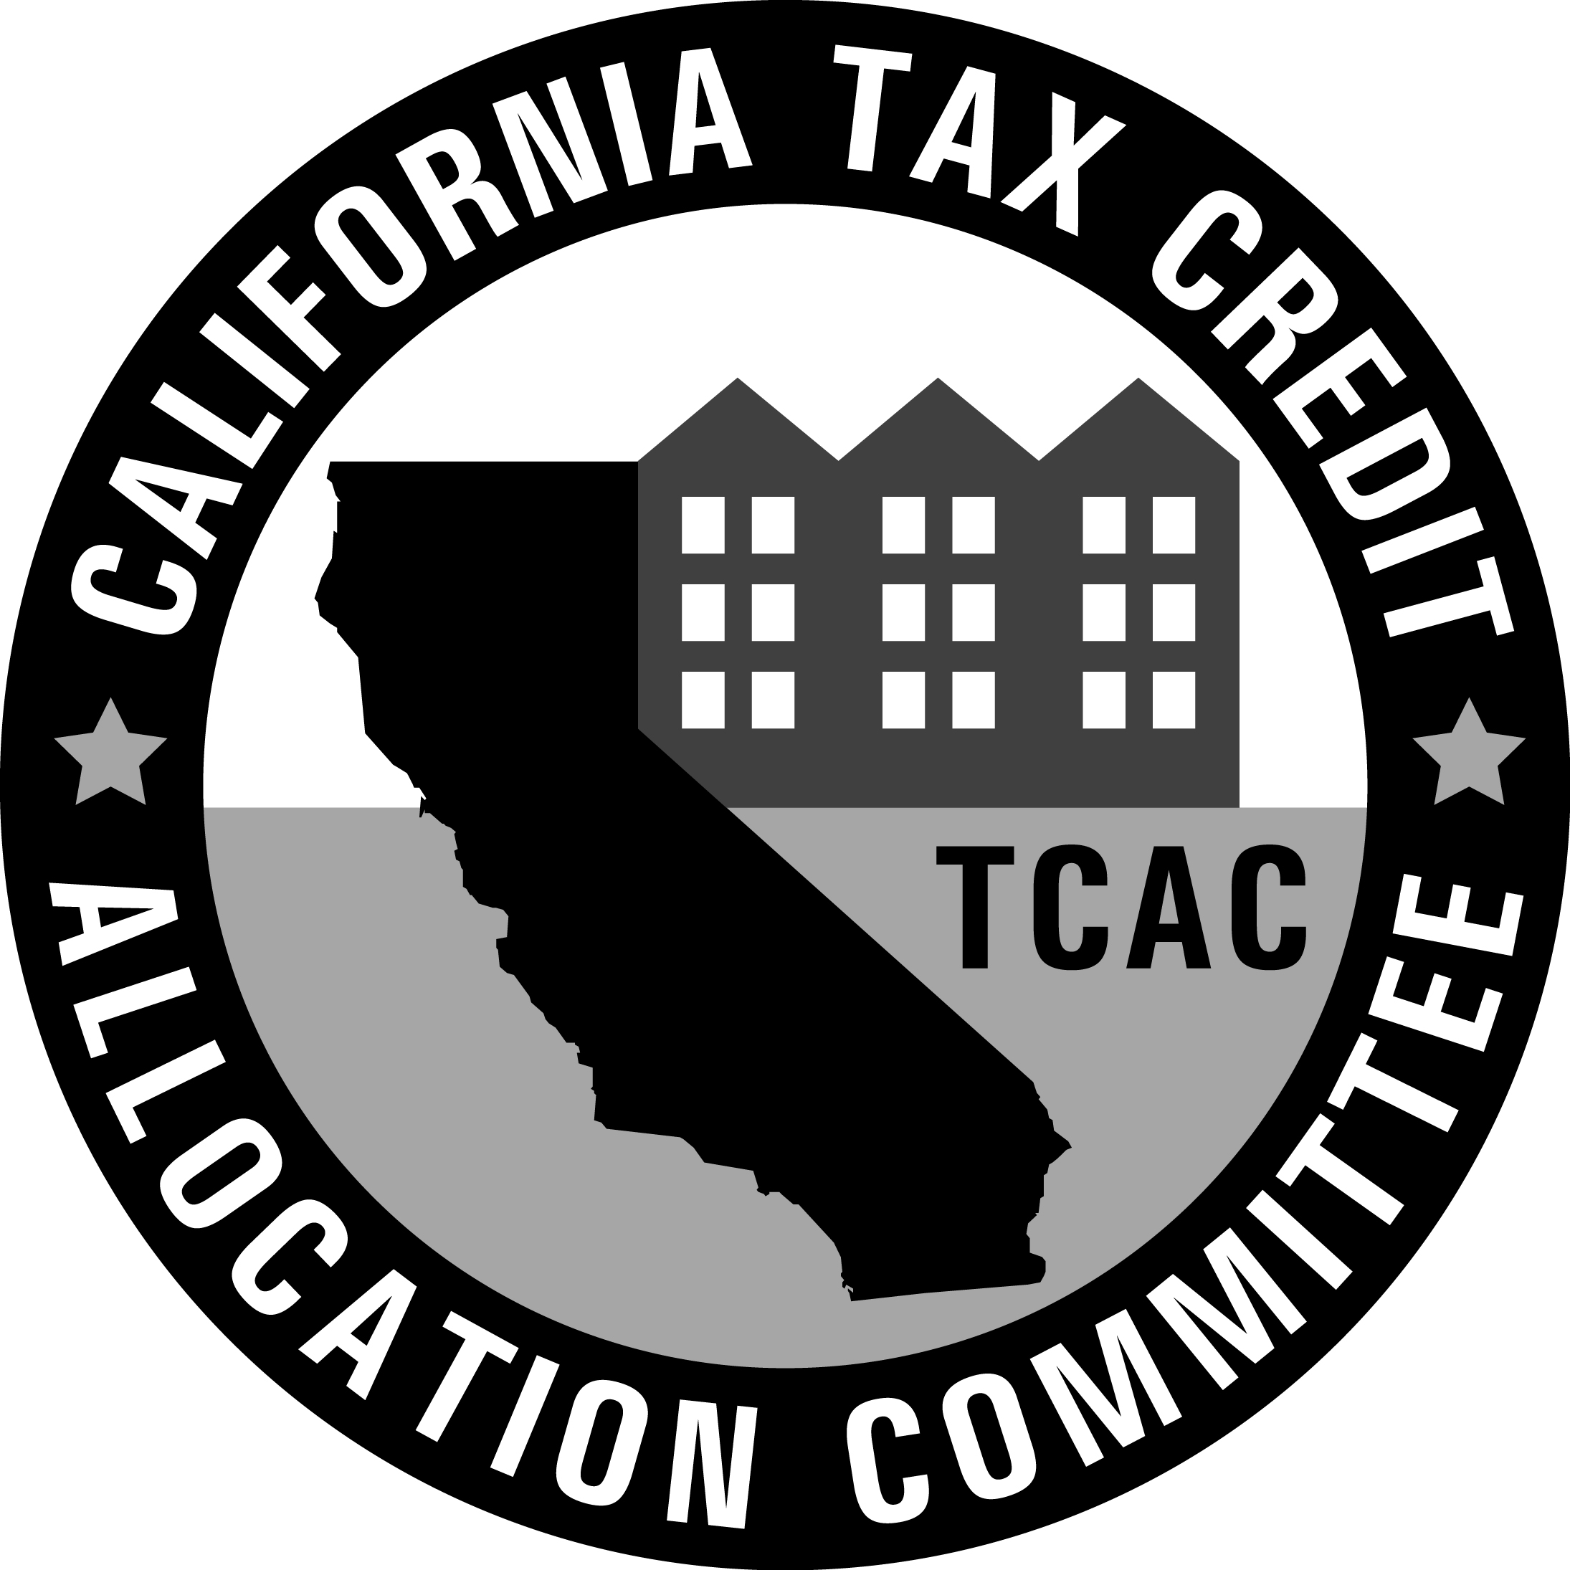 | Tax Credit Allocation Committee
ATTACHMENT 18(A)
Local Development Impact Fees

Itemize all local impact fees to be paid. The total must correspond with the total local impact fees line item shown in the development budget of the application.

Pursuant to Regulation Section 10302(x), Local development impact fees are defined as: The amount of impact fees, mitigation fees, or capital facilities fees imposed by municipalities, county agencies, or other jurisdictions such as public utility districts, school districts, water agencies, resource conservation districts, etc.

NOTE: Permit processing fees, building permit fees, and plan check fees are NOT considered local development impact fees.

TYPE OF FEES TO BE PAID | AMOUNT OF FEE
Community Development Fees | $
Drainage Facilities | $
Facilities Assessment | $
Fire Facilities | $
General Facilities | $
Governmental/Environmental | $
Law Enforcement Facilities | $
Library Facilities | $
Parks & Recreation | $
Public Facilities | $
Schools | $
Streets & Signals | $
Traffic Fees | $
Waste Water Collection | $
Waste Water Treatment | $
Water Facilities | $
Other (specify): | $
Other (specify): | $
Other (specify): | $
Other (specify): | $
Other (specify): | $
Total Local Development Impact Fees | $

Print Agency / Jurisdiction Name |  | Phone
Print Name |  | Email
Print Title |  | Signature |  | Date

