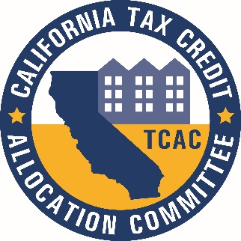
California Tax Credit Allocation Committee

2022 Meeting Schedule and Application Due Dates

Four Percent (4%) Application Deadline for Corresponding Meeting Date | Nine Percent (9%) Application Deadline for Corresponding Meeting Date | 2022 CTCAC  Committee Meeting Dates/Times* | Proposed Rounds and Topics**
 |  | January 19, 2022  11 a.m. | Minimum Point Requirement
 | March 1, 2022 | June 15, 2022  1 p.m. | 9% Awards  Round 1
March 16, 2022 |  | June 15, 2022  1 p.m. | 4% Awards  Round 1
 | June 30, 2022 | September 28, 2022  9 a.m. | 9% Awards  Round 2
July 7, 2022 |  | October 19, 2022  9 a.m. | 4% Awards  Round 2

* CTCAC meetings begin upon adjournment of CDLAC meetings. Meeting locations may change for each meeting date. Please check agendas.
**Meeting dates and times are subject to change with public notice. Topics listed are not necessarily the only topics to be discussed at the meetings. Topics will be posted in the agenda found on the CTCAC Website Meeting Page 10 days prior to the meeting date.

