
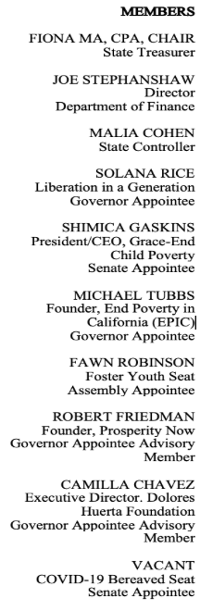

ADDRESS

Jesse Unruh State Office Building

915 Capitol Mall,

Sacramento, CA, 95814

Teleconference Location:
Los Angeles Conference Room
Reagan State Building
300 S. Spring Street (south tower), Suite 8500
Los Angeles, CA 90013

PHONE
(279) 231-1591

EMAIL
hopeforchildren@treasurer.ca.gov

WEB
www.treasurer.ca.gov/hope

NOTICE OF HOPE BOARD
BOARD MEETING AND AGENDA

Wednesday, February 25, 2026, 10:00 AM – 12:00 PM

Jesse Unruh State Office Building

915 Capitol Mall, Board Room CR 121 (First Floor)

Sacramento, CA, 95814

Public Online Participation

+1 916-573-6313,760464849# United States, Sacramento

Toll free number: 800-722-8415.

Phone conference ID: 760 464 849#

Microsoft Teams Video Conferencing Weblink
Meeting ID: 267 799 275 469 32
Passcode: GK6Bn9LX

- Call to order and roll call

- Action Item- Approval of Minutes from October 1, 2025, HOPE Governing Board Meeting
Stephanie Tom

- Information Item- Introduction of Interim Executive Director
Patrick Henning, Chief Deputy Treasurer

- Information Item- Executive Director Report
Cassandra DiBenedetto, Acting Executive Director

- Information Item- Program Manager Introduction and Report
Michael Gillis, Program Manager

- Information Item- Introduction and Update from Program Administrator
Michael Gillis, Program Manager and TIAA staff

- Information Item- Program Launch & Account Creation Flow
Cassandra DiBenedetto, Acting Executive Director

- Information Item- Update on Current RFP's in Progress
Cassandra DiBenedetto, Acting Executive Director

- Information Item- Update from Early Wealth Partnership
Amanda Feinstein, Director, Early Wealth Partnership (EWP)

- Information Item- Key Partnership Highlight
John Burton Advocates for Youth (JBAY)

- Information Item- Summary of Board Direction
Cassandra DiBenedetto, Acting Executive Director

- Adjournment

There will be an opportunity for public comment before the end of each item.

Note: Items designated for information are appropriate for HOPE Board action if the HOPE Board chooses to take action. Items may be taken out of order.

The agenda is also available on the HOPE website at:
https://www.treasurer.ca.gov/hope/meeting/index.asp

FOR ADDITIONAL INFORMATION
Cassandra DiBenedetto, Acting Executive Director
California HOPE Board
915 Capitol Mall, Sacramento, CA 95814
(916) 651-2669

The California HOPE Board complies with the Americans with Disabilities Act (ADA) by ensuring that the facilities are accessible to persons with disabilities, and providing this notice and information given to the members of the Board in appropriate alternate formats when requested. If you need further assistance, including disability-related modifications or accommodation, you may contact staff no later than five calendar days before the meeting at (279) 231-1591
or Telecommunications Device for the Deaf (TDD) at (916) 654-9922.

